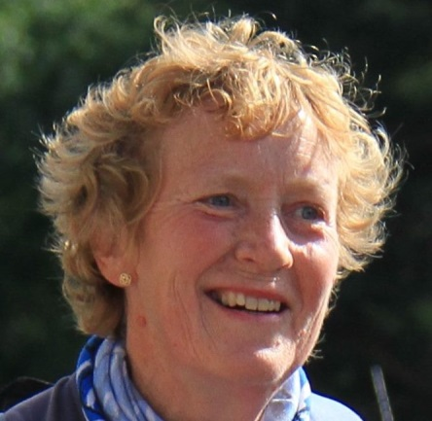
TWENTY-ONE AND COUNTING . . .
By Fiona Findlay, Kinloch Rannoch
It is hard to believe that this will be my twenty-second “25”. I ran my first event in 1990 – so that makes 550 miles of stunning scenery.
There’s been a new hall, new buses, new footpaths but the same old familiar faces each year – perhaps we are all just growing older gracefully.
It’s been a real privilege to have taken part in the event for so long – the important things have never changed – the unique atmosphere, camaraderie, friendly welcome, impressive organisation (despite what the weather throws up, often at the last minute) and of course the main reason for it all, raising money for the Highland Hospice and other charities.
I have always enjoyed being in the hills and in the early 90’s was beginning to take part in some hill races. A friend, living in Sheffield, had seen the event advertised in a hill running magazine so we decided to give it a try. Not being a fast runner the terrain sounded perfect to me – rough and boggy! I always felt a bit guilty entering the GWC as it clashes with our local Highland Games and Hill Race so I will always be grateful to the people of Rannoch who so generously sponsor me – I hardly need to ask them anymore.
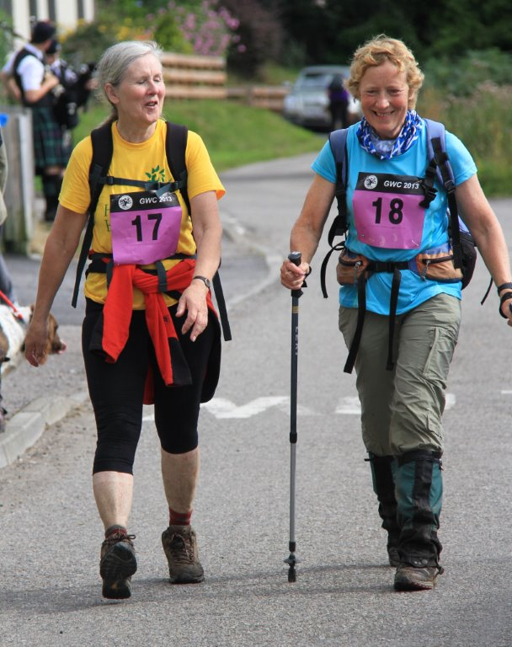
The Bad Bog lived up to its name in the early years and to me it has never been the same since the path was built! On my first event I remarked to one of the Coastguards manning the checkpoint that he was a bit far from his usual terrain. His reply that they were there to suck us out of the bogs was not far from the truth.
The past 22 years have provided every weather condition imaginable – one year on the ‘wet weather alternative’ we may as well have been running in a river for the entire course. Other years have seen runners sitting in the River Ewe at the finish to cool off.
One thing is constant though – the midges – I have always thought it should be the checkpoint guys who get the medals for tolerating them hour after hour and still remaining cheery. I am sure the midges bring in far flung relatives on GWC day . . . .
Despite having run the GWC for many years my personal challenge was the 2000 event which I walked having just completed radiotherapy in the June, following a diagnosis of breast cancer. This gave me the confidence to get back into the hills and continue doing all the outdoor Hazel Keiro and Fiona at Poolewe 2013 activities I had previously enjoyed. I ran several ‘25’s after that but a few years back decided it was time to go down a gear from running to walking. This decision may have been triggered by a comment at the start that year that there were youngsters running that year that had not even started primary school when ‘us oldies’ did our first GWC!
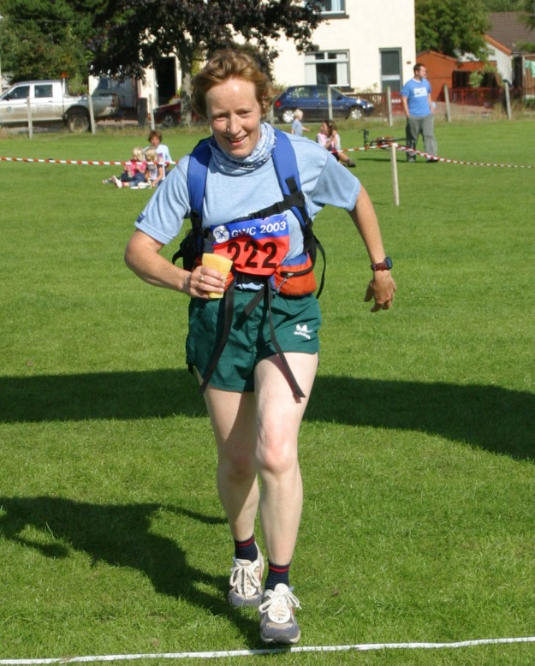
Walking however has many advantages – no worries before the start about:
  - Eating/drinking too much/too little
  - Feeling sick on the bus – it doesn’t matter quite so much if you are not about to set off running!
  - Not having done enough training.
  - Everyone else looking much fitter etc. etc.
  - The views are spectacular whatever but probably safer to appreciate whilst walking!
  - Being able to enjoy all the goodies on offer at Carnmore and Kernsary – I even remember the year that there were Bonios laid out in rows from large to small for the canine participants!
When I started to write this I realised just how many memories of the GWC I have and I am just one participant – maybe that should be another fundraiser for the Highland Fiona at Ullapool GWC in 2003 Hospice – a book of GWC memories!
It has been a wonderful journey - hopefully for many more years to come the GWC will be a fixture in my calendar.
See you all in August.
Fiona has consistently been a loyal supporter and leading fundraiser in the Challenge and to date (2013) has raised over £5000 - and driven 6732 miles for the pleasure!
Fiona is consistently one of the best fundraisers in the Challenge. She

